ORDER 2015 HOLIDAY WREATHS AND MENORAH CANDLES
TO SUPPORT BLAIR CREW AT
MONTGOMERY BLAIR HIGH SCHOOL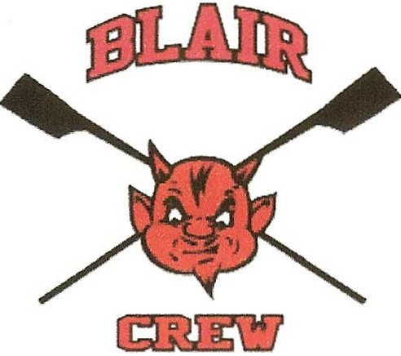

Blair Crew’s annual wreath and candle sale is on! This fundraiser makes up a significant portion of crew’s operating budget. As a club sport, Blair Crew receives no funding from school or county. Coaches’ salaries, equipment costs, and race fees all come from team dues, donations, and our HOLIDAY FUNDRAISER. Wreaths and candles will be delivered to your door after Thanksgiving.

YES! I want to order to support Blair Crew!

____ double-sided balsam wreath/s with red bow @ $21.50 each = $________

____ box/es Menorah candles @ $15 each = $ _________

Make check payable to Blair Crew. Total $ ____________ check # ___________

Customer’s name___________________________________________________

Address___________________________________________________________

Telephone ________________________ Email __________________________

Rower’s name __________________________Rower’s tel__________________

Return this form and check to rower or mail to Kristin Staroba 10 Sherman Ave, Takoma Park MD 20912 kristin.staroba@gmail.com 202-779-2600

Keep this part for your receipt: Customer name____________________________
Total paid: $ ________ Date: ________ # wreaths _____ # boxes candles_____
Blair Crew member’s name__________________________ tel _______________
THANK YOU FOR SUPPORTING BLAIR CREW!

